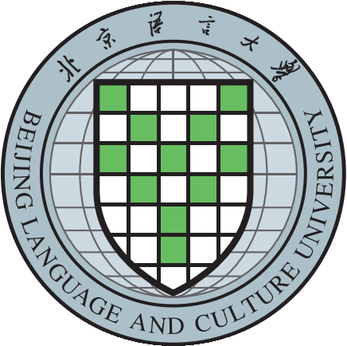
International Visitor Request Form
Name of University/Institution
Country/Region
Visit Start Date & Time | DD/MM/YYYY
Visit End Date & Time | DD/MM/YYYY
Purpose of Visit  (Check all that apply) | General Partnership ☐
Purpose of Visit  (Check all that apply) | Joint or Dual Programme ☐
Purpose of Visit  (Check all that apply) | Student/Staff Exchange Programme ☐
Purpose of Visit  (Check all that apply) | Agreement Signing ☐
Purpose of Visit  (Check all that apply) | Summer/Winter Vacation Programme ☐
Purpose of Visit  (Check all that apply) | Other ☐ | Please nominate the specific area/topic of interest for discussion:
Purpose of Visit  (Check all that apply) | Nothing at this time ☐
Brief Info About Your University/Institution | (example: website, ranking, distinguishing characteristics)
Member of the Visiting Delegation | Example:  FULL NAME, TITLE, POSITION, GENDER
Primary Contact of the Visit | Name/Title |  |  | Contacts  (Tel/Email)
The Person(s) You Would Like to Meet  (if any) | (eg: Mr. Li Zhongzhong, Dean of Art Department at BLCU)
Others
(if any)

*BLCU International Cooperation and Exchanges Office welcomes international delegations to our campus. Please submit the International Visitor Request Form above to international@blcu.edu.cn at least two weeks (14 days) prior to the proposed visit date. You will receive a response to your enquiry within 5 working days. We look forward to your visit and opportunities for mutual collaborations between our institutions.

